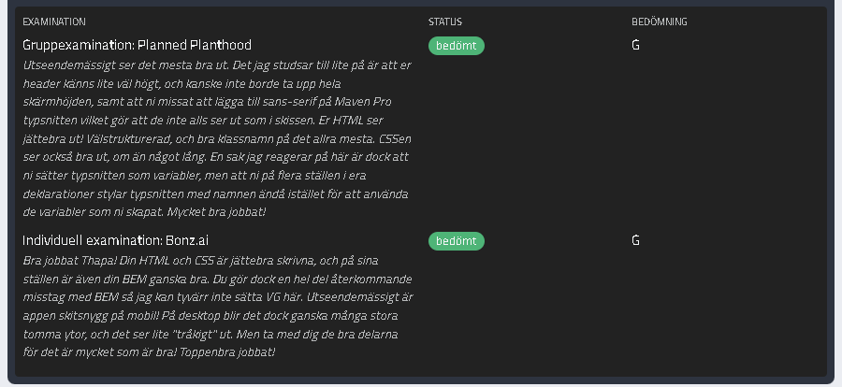

**Examination**

**Status**

**Assessment**

**Group Examination: Planned Planthood**  
Most of the visual aspects look good. What I stumble a bit on is that your header feels a bit too tall, and perhaps shouldn’t take up the full height of the screen. Also, you missed adding sans-serif to the Maven Pro fonts, which means they don’t look like they do in the mockup. Your HTML looks excellent—well-structured, with good class names for the most part. The CSS also looks good, although a bit long. One thing I noticed is that you set the fonts as variables, but in several places in your declarations you style the fonts using their names instead of using the variables you created. Very well done!

**Assessed**

**G**

**Individual Examination: Bonz.ai**  
Great job, Thapa! Your HTML and CSS are very well written, and in some places your BEM is also quite good. However, you make a number of recurring mistakes with BEM, so unfortunately I cannot give you a VG here. Visually, the app looks fantastic on mobile! On desktop, however, there are quite a few large empty areas, which makes it look a bit “boring.” But take the positive parts with you—it’s very well done overall! Excellent work!